MEMBERSHIP APPLICATION
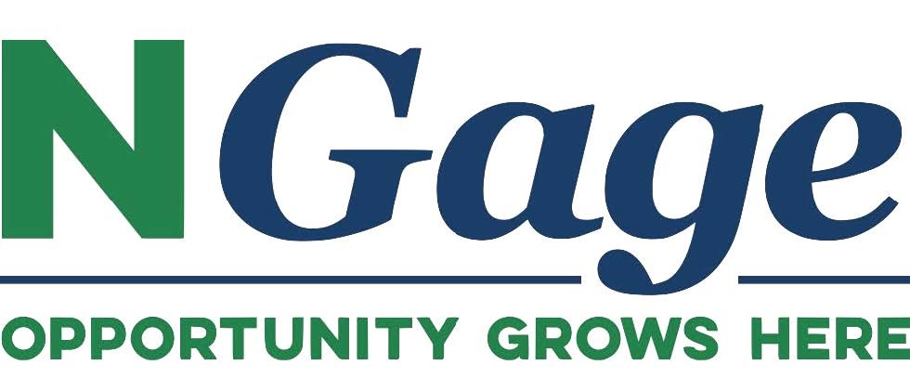

Member Information (please print or type):

Business Name

Contact Person

Address

City, ST Zip Code

Phone Number

Email Address

Website
Facebook Page | @

Phone Number

Email

Business Description for NGage website:

Membership Level | Annual Investment | Direct Member Benefits
Leader | $5,000 | Voting rights; featured business recognition, business profile, and logo/link to business and Facebook on NGage website; up to five photos and one video featured on NGage website
Champion | $2,500 | Voting rights, featured business recognition, business profile, and logo/link to business and Facebook on NGage website; up to three photos and one video featured on NGage website
Catalyst | $1,000 | Voting rights, featured business recognition, business profile, and logo/link to business and Facebook on NGage website; up to two photos featured on NGage website
Advocate | $500 | Business profile and logo/link to business and Facebook on NGage website
Associate | $100 | Business profile and logo/link to business and Facebook on NGage website

NGage Member Investor Pledge & Acknowledgement:

I (we) pledge to be a member at the level.

Signature(s) |  | Date

Please make checks payable to:
Gage Area Growth Enterprise
218 N 5th Street
Beatrice, NE 68310

Application forms may be mailed with checks or emailed to:
walkerz@ngagegroup.org

Your expertise, vision, and investment help create a more vibrant and economically sound county. The magnitude of our member investors verifies to business prospects that opportunity grows here.

